

WEB DEVELOPMENT



OWEN BALL

UNIVERISTY OF COVENTRY

Contents

The leader board page 3

The Login Page 5

Login Errors 6

The Register Page 6

Register Errors 7

Flag Page 8

Profile Page 8

Database 9

The Navigation Bar 9

Code 10

CSS 10

Flags.css 10

Form.css 11

Leaderboard.css 12

Login.css 14

Profile.css 15

Style.css 16

Php 17

Dbh.inc.php 17

Flag.php 17

Functions.php 19

Leaderboard.php 22

Login.inc.php 32

Login.php 33

Logout.inc.php 34

Profile.php 35

Sign_up.inc.php 36

Sign_up.php 37

Scripts.js 39

# The leader board page

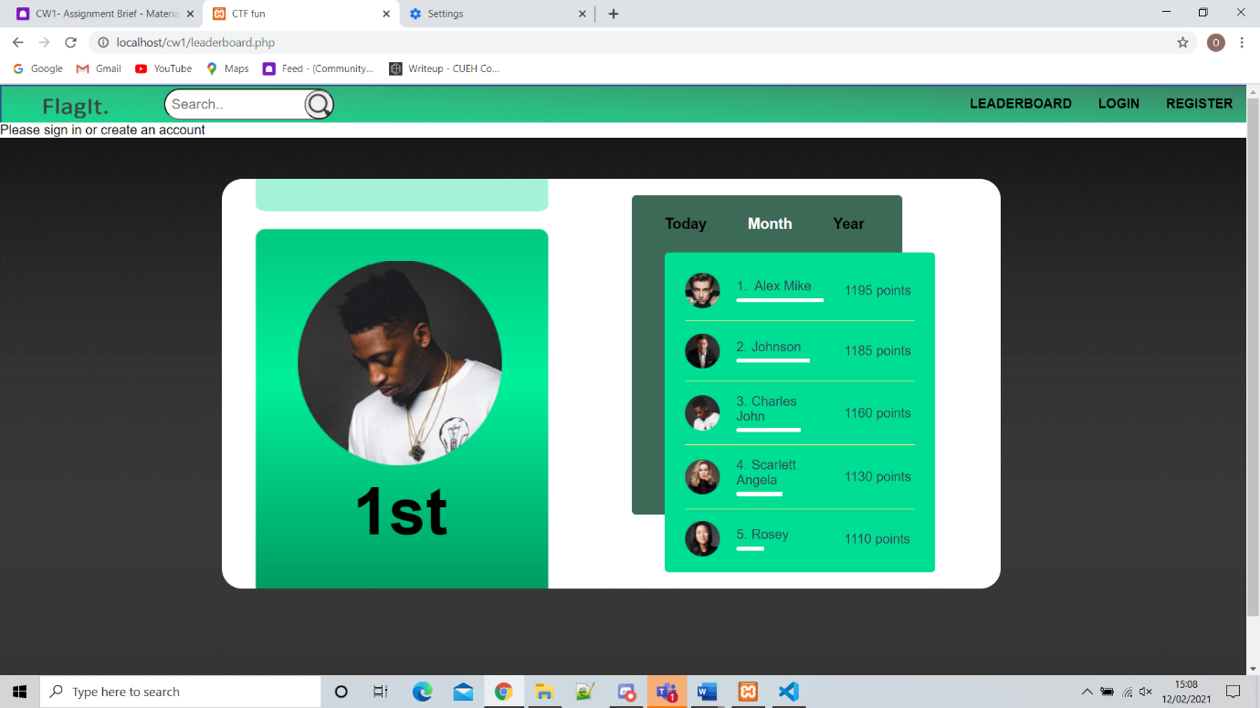This displays the “leaderboard” page with today’s winner on the left (who came first today) and a column to the right written in JavaScript showing the positions of the top 5 players. This column includes their points they have earnt, a bar displaying their progress on the total amount of points that can be won (including their points) and their own profile picture.

This first screen shot is again the “leaderboard” page but showing who won overall in the month with the same data as described from above but with the month highlighted instead of Today or Year. With an additional screen shot showing the same information but for the year.

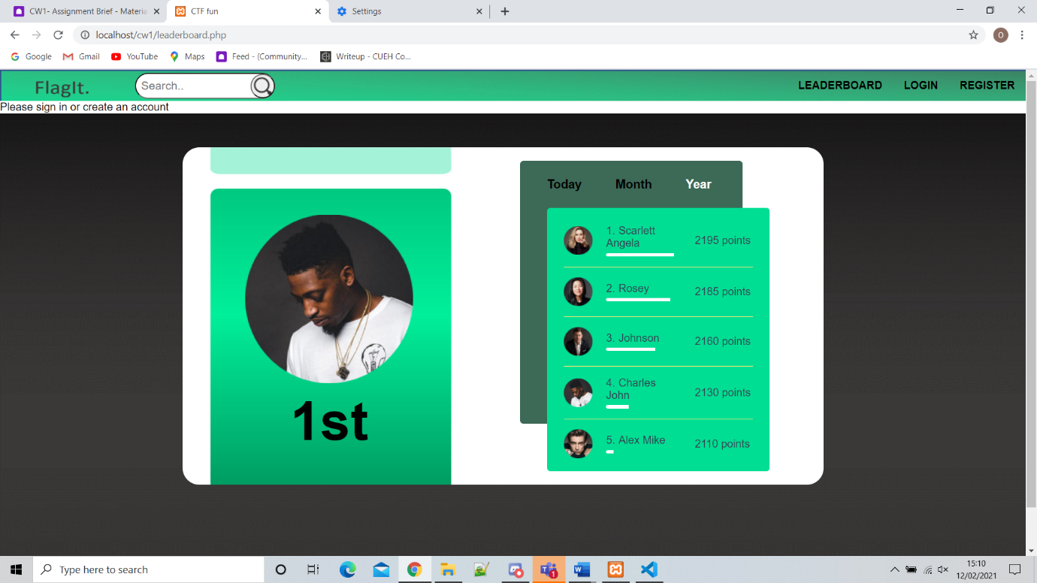This second screen shot is again the “leaderboard” page but showing who won overall in the year with the same data as described from above but with the year highlighted instead of Today or Month.

# The Login Page

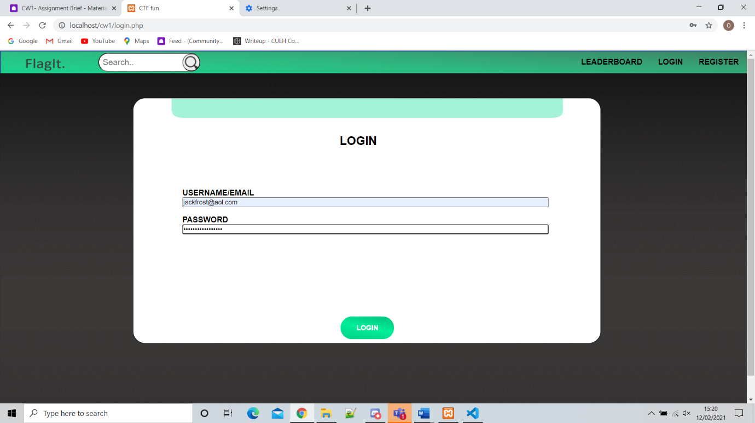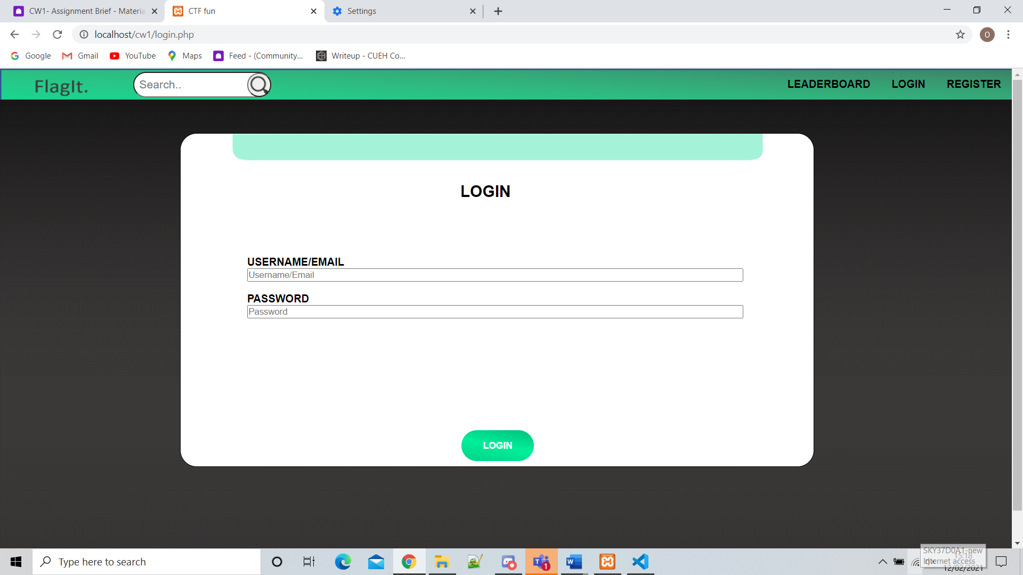

As shown above this is the login page with a place to type your username or email and a password box which when typed in goes to asterixis (shown in picture B). Once correct login details are entered the page will automatically be sent to the flag screen with a new navigation bar with extra options due to you being signed in

## Login Errors

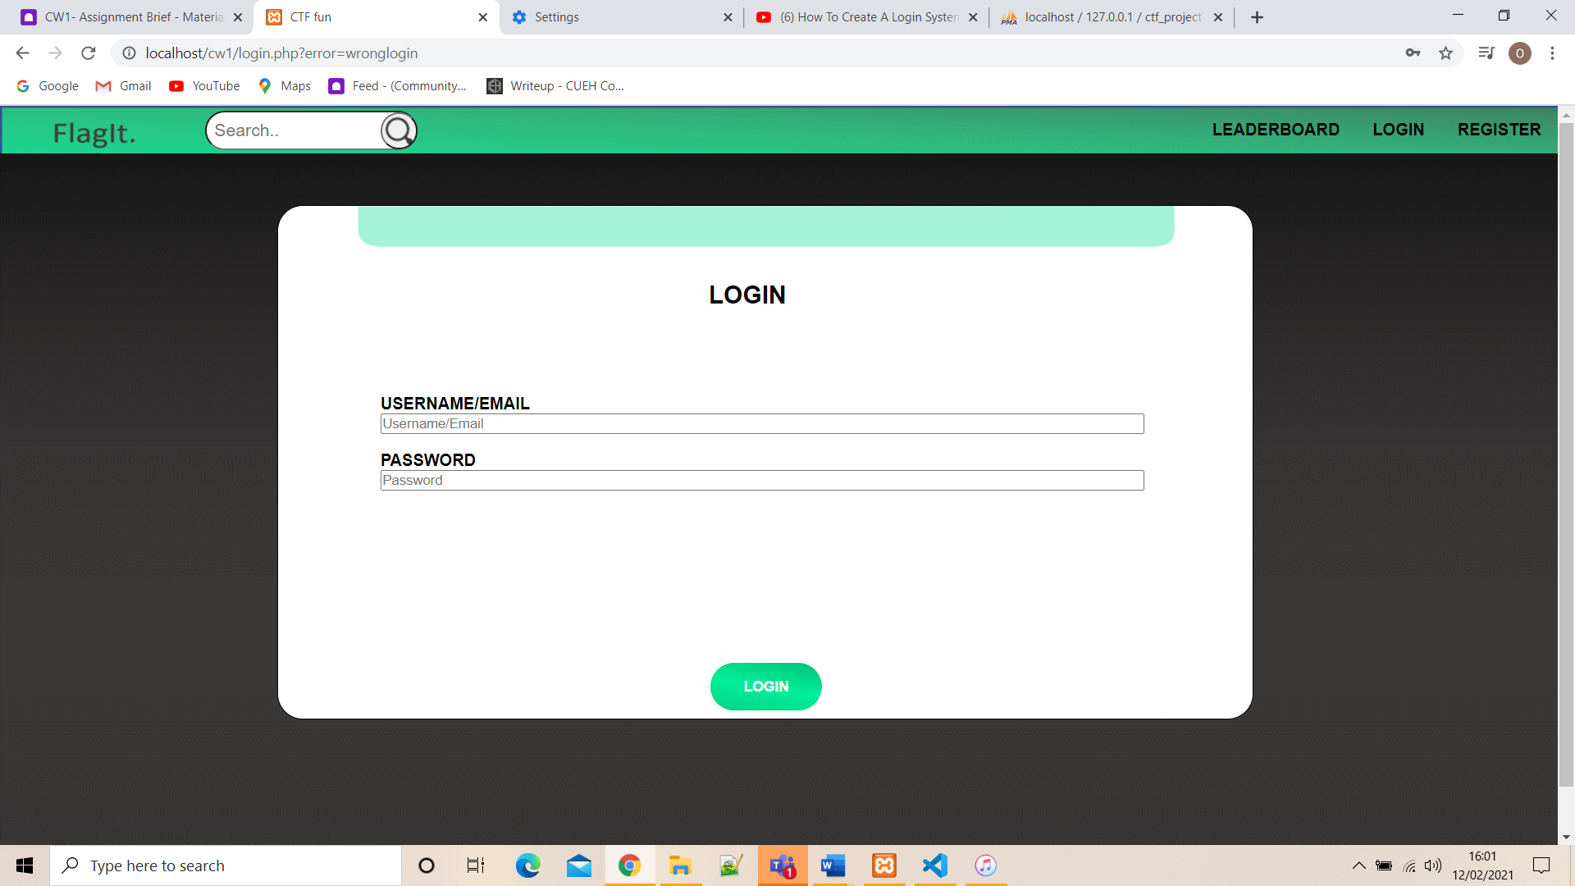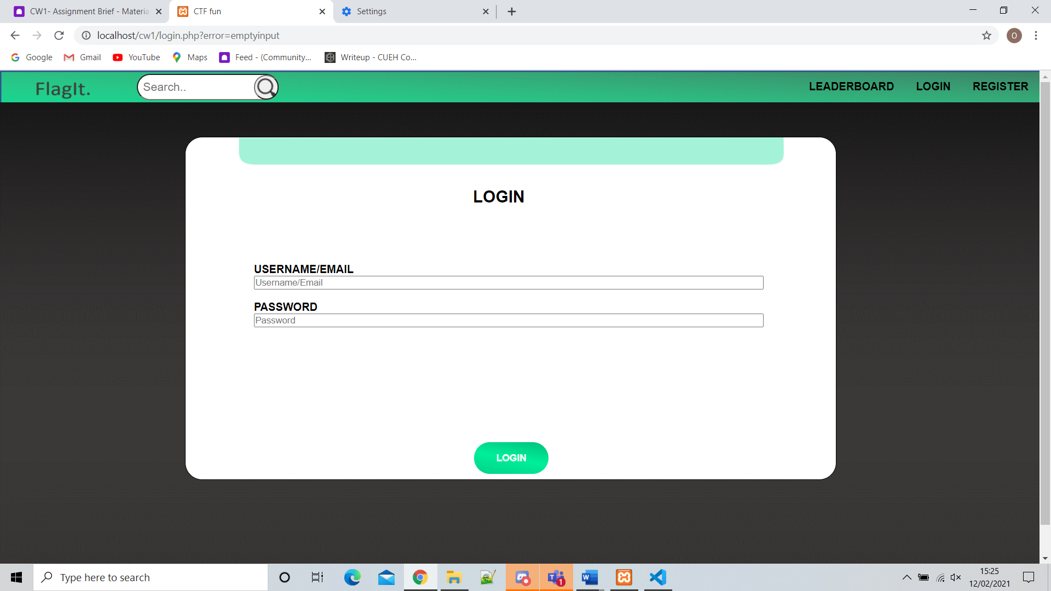If Any of the boxes are left empty then the following error will occur “emptyinput”

If the wrong login details are entered “wronglogin” error will be displayed for either password or username as I it would be a flaw in the website if it displayed which one was wrong due to hackers being able to exploit this and discover which usernames exist and which don’t.

# The Register Page

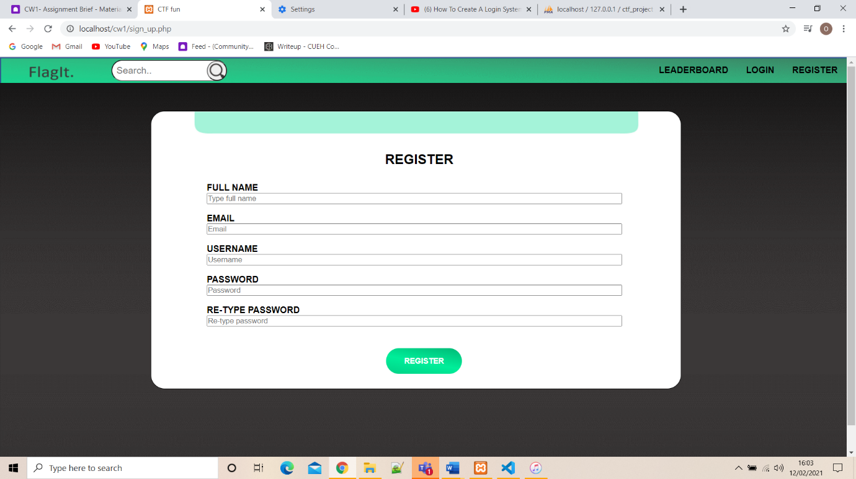Screenshot above displays the “register” page linked in with the database. You must enter your full name, email, username, password (asterixis) and a repeat of the same password. If all the details are correct a user Id is created incremented from the last created user the details name, username, email are added to that set of data, the password is encrypted with BCrypt (constantly updating to stay ahead and secure for php encryptions) and finally added to the last column. The password is hashed to be more secure.

## Register Errors

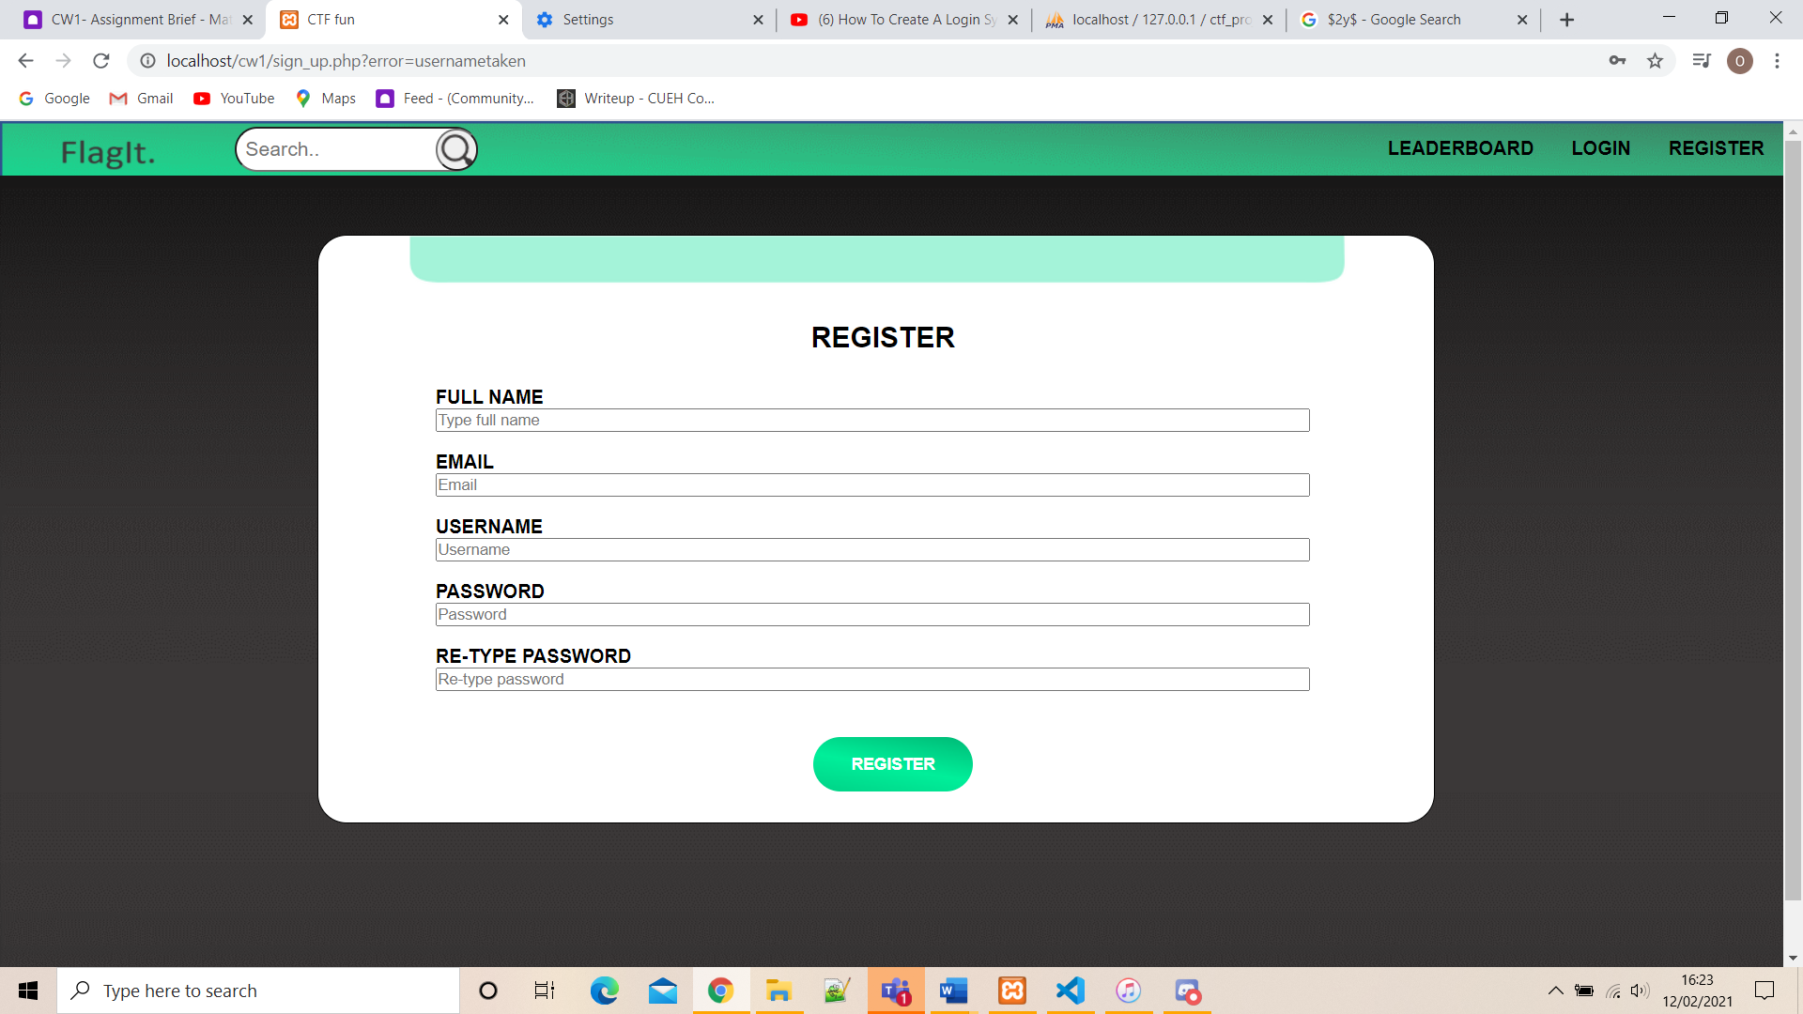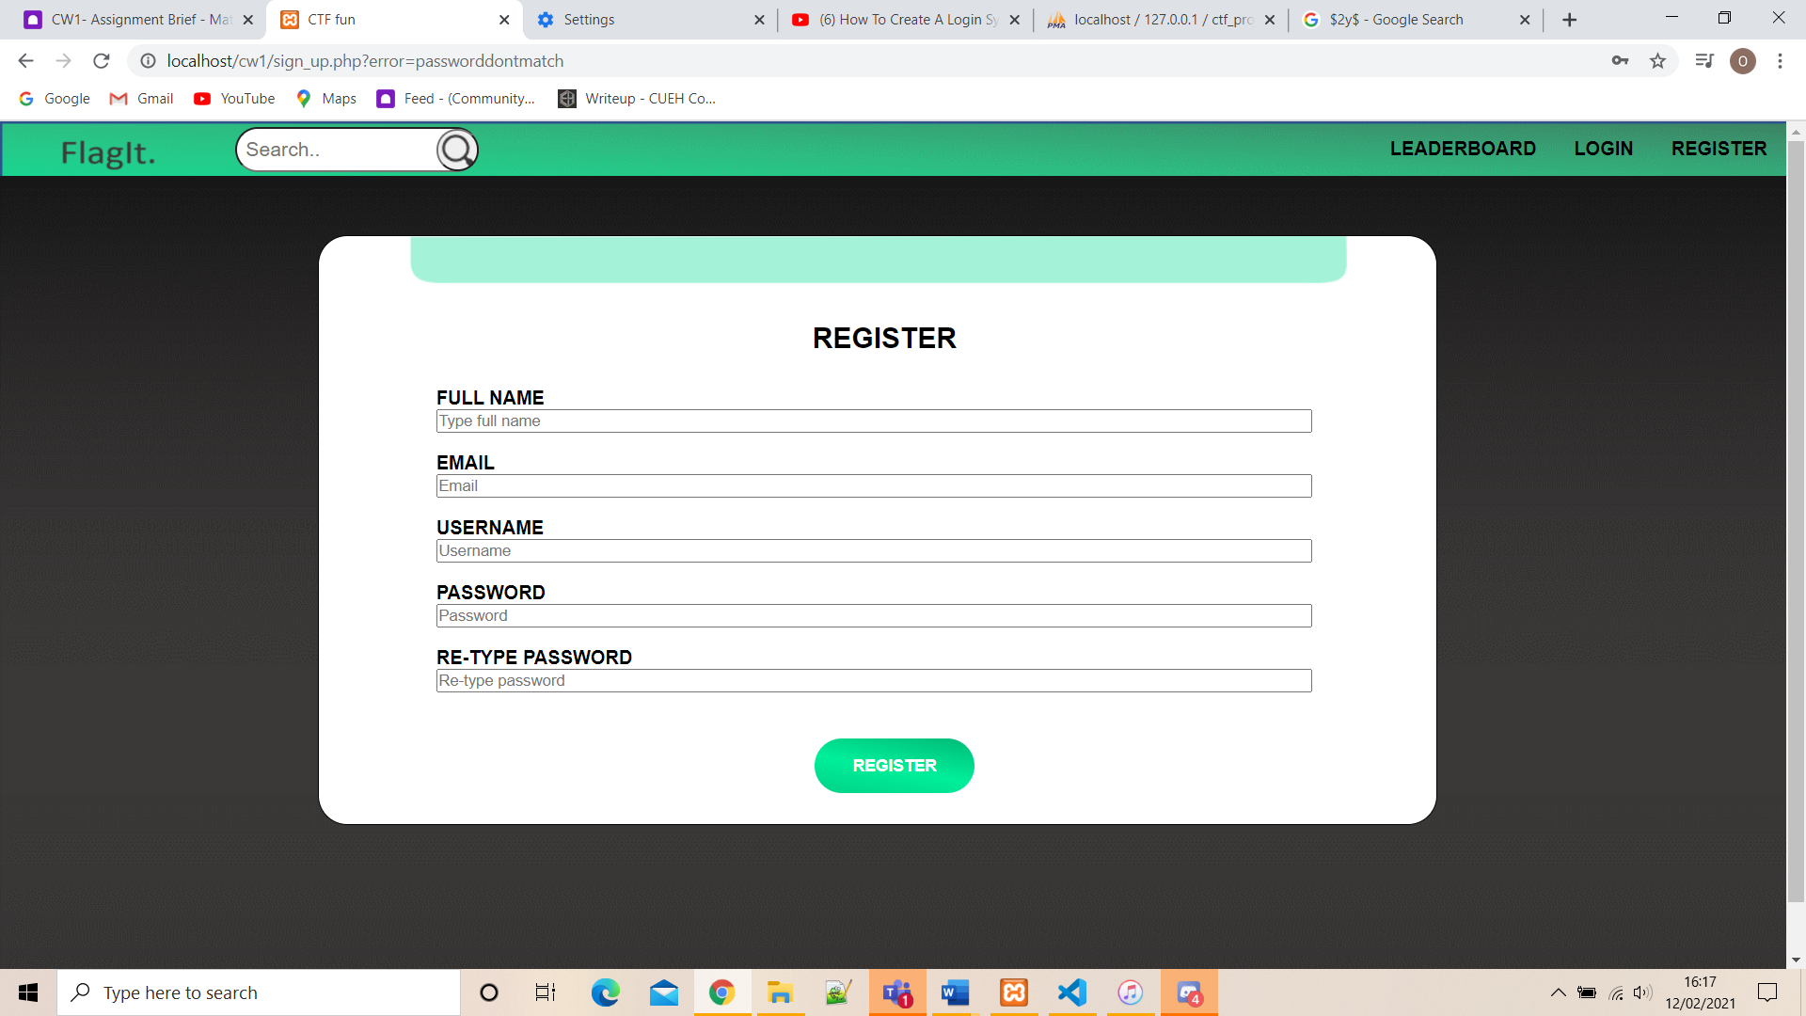If the passwords do not match when registering the following error will occur “passworddontmatch”

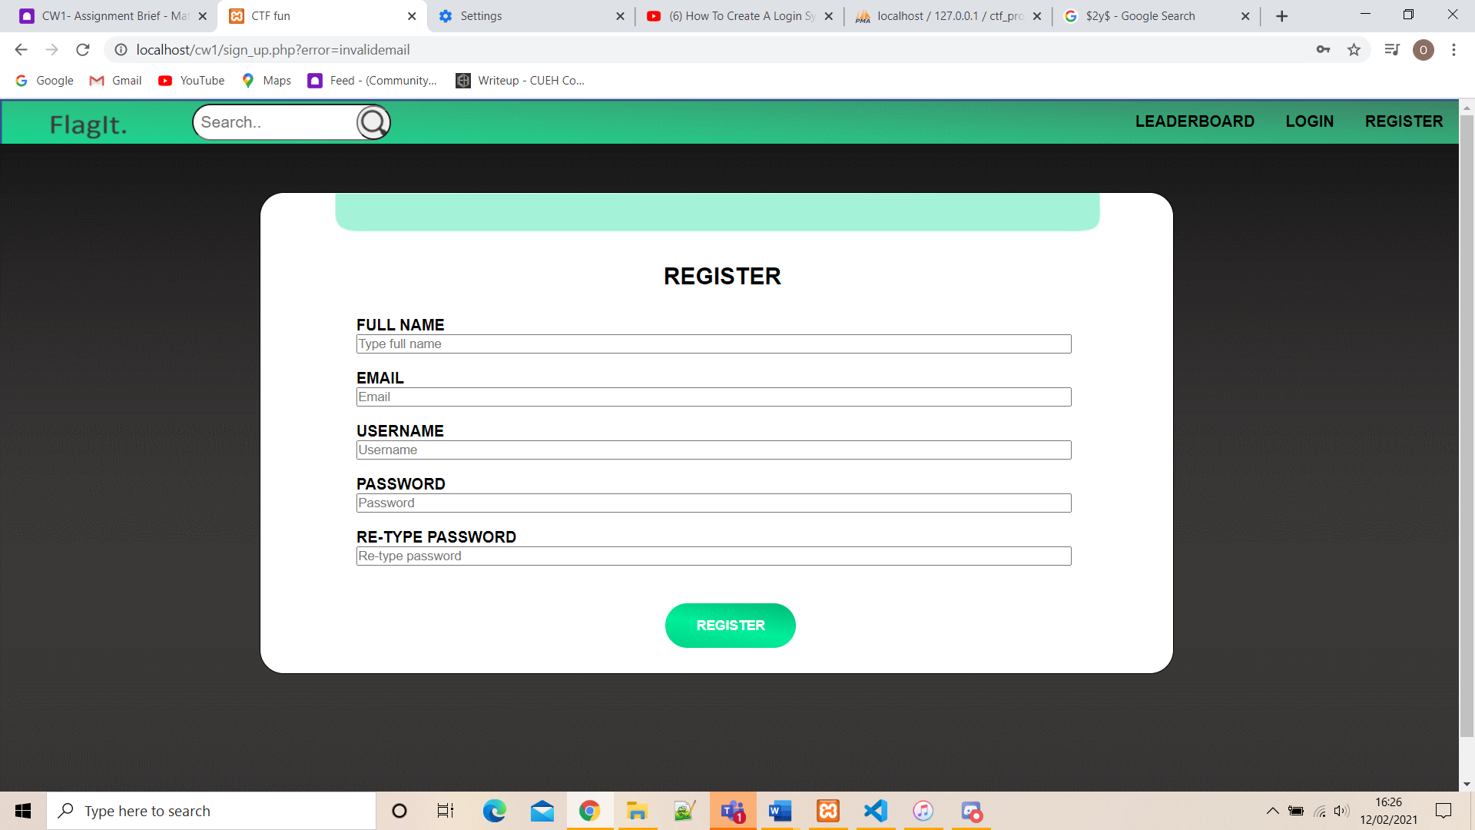A function will check the database for any existing usernames with the same username entered and if found the error “usernametaken” will occur

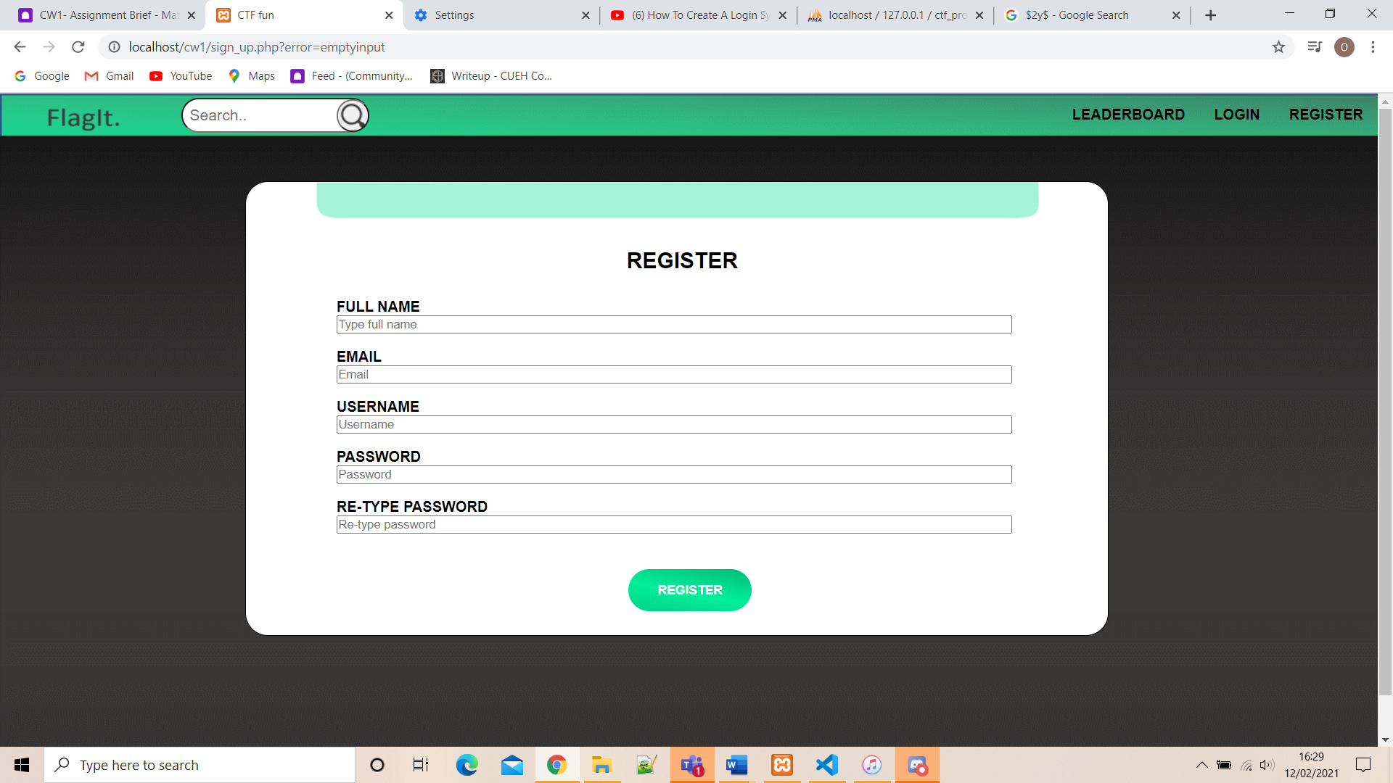A function implemented in php checks for correct email addresses, therefore if the email entered isn’t valid the following error will occur “invalidemail”

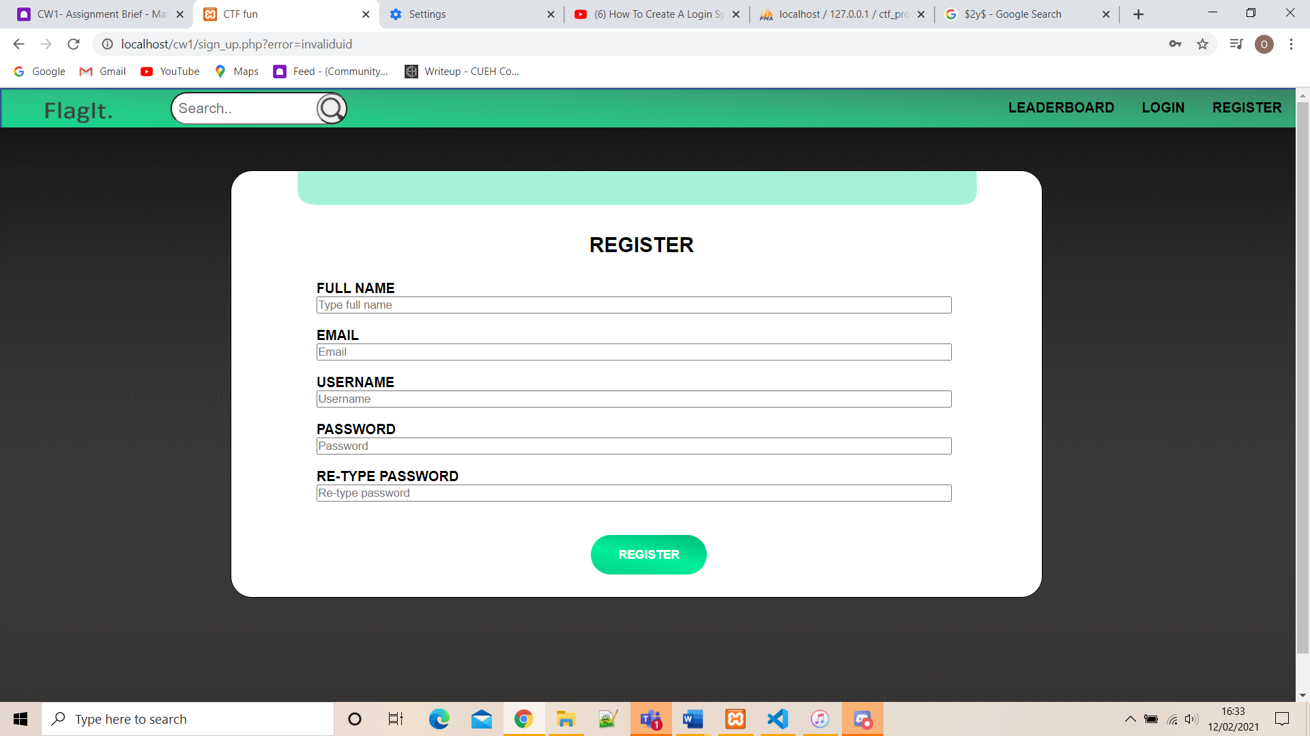If any of the boxes are left empty then the following error will occur “emptyinput”

If the username entered contains characters such as “/”then the error “invaliduid” will occur

# Flag Page

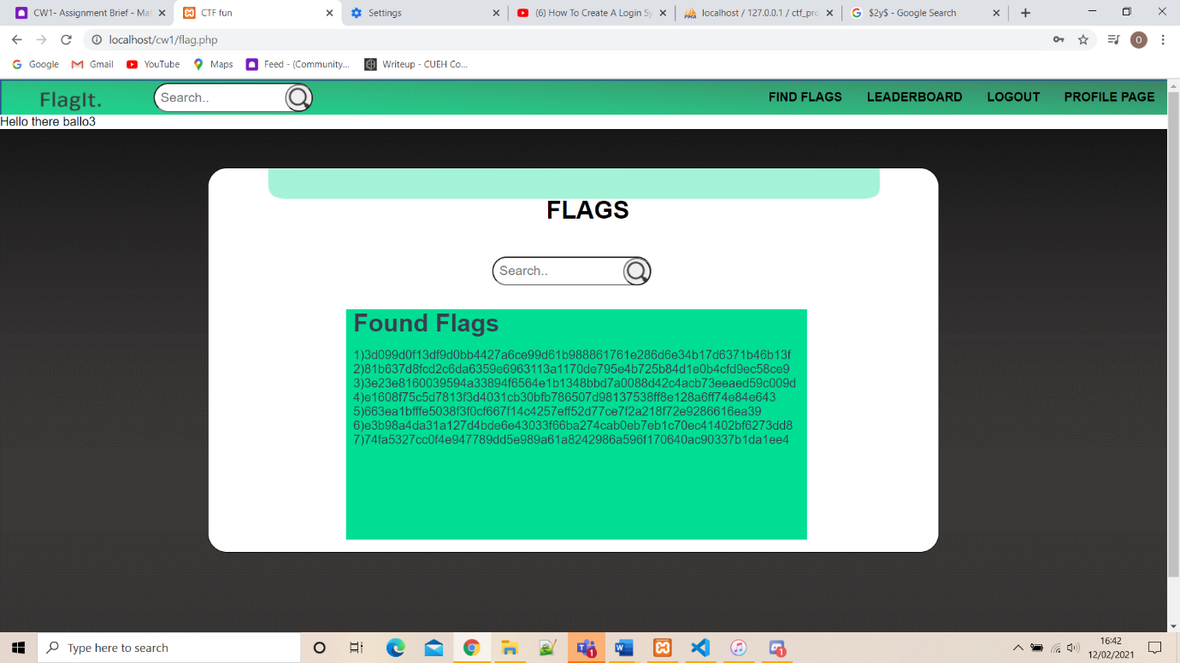The “Flag Page” is shown when a user is logged (directly sent to this page), it displaying the current flags obtained as well as a search bar with a button including to add and get more points when a flag is found.

# Profile Page

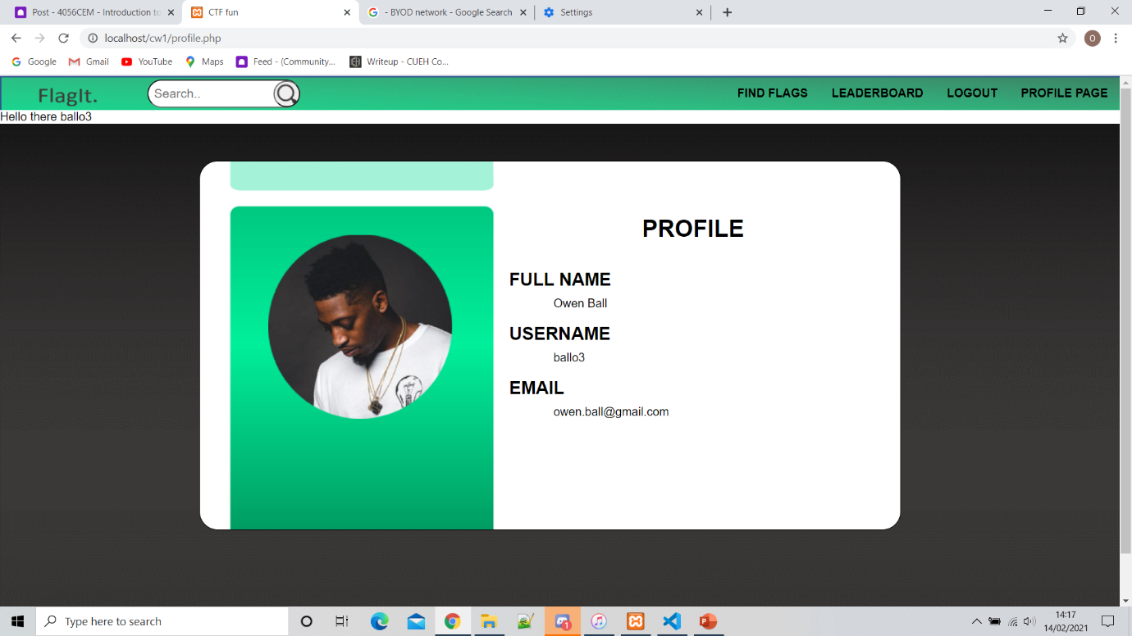

The “Profile Page” is shown when a user is logged in where you can see the information of the current user including email, username and profile picture all using php with session management. Therefore will change as users log in

# Database

The following picture shows us the database created using SQL and phpMyAdmin. A project called “ctf_project” (named after the website) is created with a table called users, consisting of 5 elements usersId for the private key (increments everytime), usersName for the full name, usersEmail for the email, usersUid for the username and finally usersPwd for the encrypted password (using BCrypt).

# The Navigation Bar

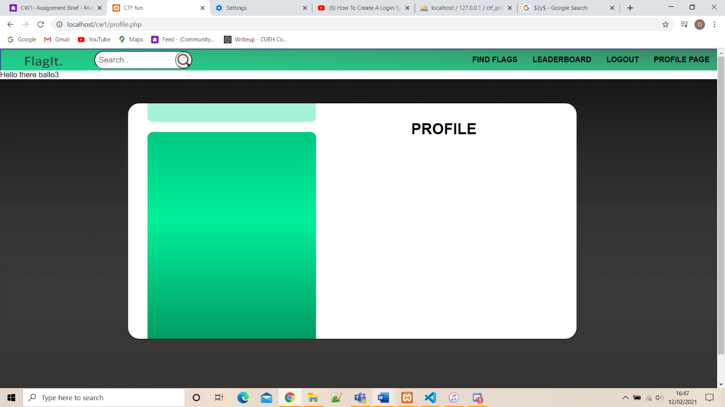This navigation bar is shown when a user is logged in with a welcoming message with ther users username displayed. On the far left is the logo of the website “FlagIt” and a search bar to find certain webpages in the website. On the right there is “FIND FLAGS” to locate to the found flags page, “LEADERBOARD” locating to the leader board page, “”LOGOUT” so users can logout their account and “PROFILE PAGE” so users can see their profile.

This navigation bar is shown when a user is not logged in with a string of text asking the user to “Please sign in or create an account”. On the far left is the logo of the website “FlagIt” and a search bar to find certain webpages in the website. On the right there “LEADERBOARD” locating to the leader board page, “”LOGIN” so users can login to their existing account and “REGISTER” so users can 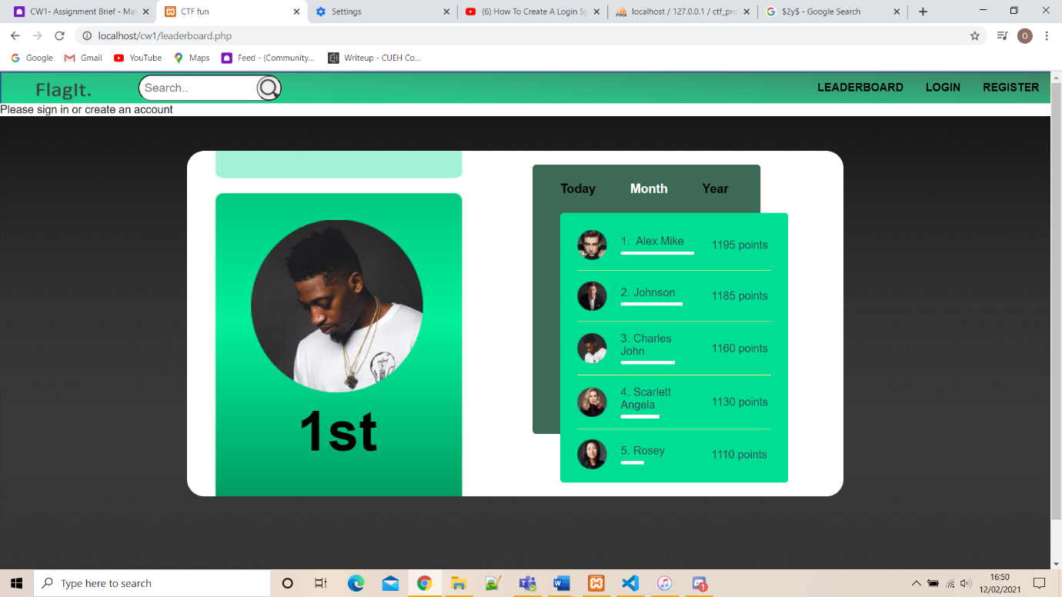create a new account.

# Code

## CSS

### Flags.css

1. *{
2. **margin**: 0;
3. **padding**: 0;
4. **list-style**: none;
5. **font-family**: 'Helvetica';
6. }
7. .FlagBackground {
8. **position**: absolute;
9. **width**: 100%;
10. **height**: 100%;
11. **background-image**: url("../images/FormBackground.png");
12. }
14. .FlagGreen h1{
15. **position**: absolute;
16. **color**:black;
17. left: 440px;
18. **font-family**: 'Helvetica';
19. }
21. .FlagGreen form{
22. **position**: absolute;
23. top: 0px;
24. left: 270px;
25. **width**: 700px;
26. **height**: 60px;
27. **background-image**: url("../images/FormBackGroundRegister.png");
28. }
30. .Flag form{
31. **position**: absolute;
32. top: 50px;
33. left: 270px;
34. **width**: 950px;
35. **height**: 500px;
36. **border**: 1px solid black;
37. **background-color**: white;
38. border-radius: 25px;
39. }
40. .flag-search input{
41. **float**:middle;
42. **padding**: 7px;
43. **margin-top**: 60px;
44. **margin-left**: 370px;
45. **font-size**: 17px;
46. border-radius: 25px;
47. }
48. .flag-search button {
49. **position**: absolute;
50. top: 110px;
51. left: 540px;
52. **height**:36px;
53. **width**:36px;
54. border-radius: 25px;
55. **margin-top**: 7px;
56. **background-image**: url("../images/Magnifying.png");
57. **cursor**: pointer;
58. }
59. .found-flags {
60. **position**: absolute;
61. top: 300px;
62. left: 450px;
63. **width**: 600px;
64. **height**: 300px;
65. **background-color**:#00DE94;
66. }
67. .found-flags p{
68. **position**: absolute;
69. top: 50px;
70. left: 10px;
71. **color**: #3a3d51;
72. }
73. .found-flags h1{
74. **position**: absolute;
75. top: 0px;
76. left: 10px;
77. **color**: #3a3d51;
78. }

### Form.css

1. .RegisterFormBackground {
2. **position**: absolute;
3. **width**: 100%;
4. **height**: 100%;
5. **background-image**: url("../images/FormBackground.png");
6. }
8. .RegisterForm h2{
9. **position**: absolute;
10. left:420px;
11. **font-family**: 'Helvetica';
12. }
14. .RegisterForm p{
15. **position**: absolute;
16. **color**:black;
17. left: 100px;
18. **font-family**: 'Helvetica';
19. }
20. .RegisterForm h3{
21. **position**: absolute;
22. **color**:black;
23. left: 420px;
24. **font-family**: 'Helvetica';
25. }
27. .RegisterFormGreen form{
28. **position**: absolute;
29. top: 0px;
30. left: 270px;
31. **width**: 700px;
32. **height**: 60px;
33. **background-image**: url("../images/FormBackGroundRegister.png");
34. }
36. .RegisterForm form{
37. **position**: absolute;
38. top: 50px;
39. left: 270px;
40. **width**: 950px;
41. **height**: 500px;
42. **border**: 1px solid black;
43. **background-color**: white;
44. border-radius: 25px;
45. }
46. .button {
47. **position**: absolute;
48. **background-image**: url("../images/FormButton.png");
49. **border**: none;
50. **color**: white;
51. **padding**: 15px 32px;
52. **font-size**: 14px;
53. **margin**: 4px 2px;
54. **cursor**: pointer;
55. border-radius: 25px;
56. **font-family**: 'Helvetica';
57. }

### Leaderboard.css

1. *{
2. **margin**: 0;
3. **padding**: 0;
4. **list-style**: none;
5. **font-family**: 'Helvetica';
6. }
7. .LeaderboardBackground {
8. **position**: absolute;
9. **width**:100%;
10. **height**:100%;
11. **background-image**: url("../images/FormBackground.png");
12. }
14. .LeaderboardGreen h1{
15. **position**: absolute;
16. **color**:black;
17. left: 440px;
18. **font-family**: 'Helvetica';
19. }
21. .LeaderboardGreen form{
22. **position**: absolute;
23. top: 30px;
24. left: 270px;
25. **width**: 700px;
26. **height**: 60px;
27. **background-image**: url("../images/LeaderboardBackGound.png");
28. }
30. .Leaderboard form{
31. **position**: absolute;
32. top: 50px;
33. left: 270px;
34. **width**: 950px;
35. **height**: 500px;
36. border-radius: 25px;
37. }
38. .personal-img{
39. **position**: absolute;
40. top: 100px;
41. left: 93px;
42. **width**: 20px;
43. **height**:20px;
44. **display**: block;
45. }
46. .Leaderboard form h1{
47. **position**: absolute;
48. top: 360px;
49. left: 160px;
50. **font-size**: 80px;
51. **font-family**: 'Helvetica';
52. }
53. .lboard_section{
54. **position**: absolute;
55. top:20px;
56. left: 500px;
57. **width**: 250px;
58. **height**: 340px;
59. **background**:#3D6957;
60. **padding**: 25px 40px;
61. **position**: relative;
62. border-radius: 5px;
63. }
65. .lboard_section .lboard_tabs ul{
66. **display**: flex;
67. }
69. .lboard_section .lboard_tabs ul li{
70. **margin-right**: 50px;
71. **font-size**: 18px;
72. **font-weight**: 600;
73. **color**: black;
74. **cursor**: pointer;
75. }
77. .lboard_section .lboard_tabs ul li:hover,
78. .lboard_section .lboard_tabs ul li.active{
79. **color**: #fff;
80. }
82. .lboard_wrap{
83. **position**: absolute;
84. top: 70px;
85. left: 40px;
86. **background**: #00DE94;
87. **width**: 100%;
88. **height**: 100%;
89. border-radius: 5px;
90. }
92. .lboard_wrap .lboard_item{
93. **padding**: 25px;
94. }
96. .lboard_wrap .lboard_mem{
97. **display**: flex;
98. align-items: center;
99. **padding**: 15px 0;
100. **border-bottom**: 1px solid #ffe773;
101. }
103. .lboard_wrap .lboard_mem:first-child{
104. **padding-top**: 0;
105. }
107. .lboard_wrap .lboard_mem:last-child{
108. **padding-bottom**: 0;
109. **border-bottom**: 0;
110. }
112. .lboard_wrap .lboard_mem .img{
113. **width**: 50px;
114. }
116. .lboard_wrap .lboard_mem img{
117. **display**: block;
118. **width**: 100%;
119. }
121. .lboard_wrap .lboard_mem .name_bar{
122. **margin**: 0 20px;
123. **width**: calc(100% - 150px);
124. }
126. .lboard_wrap .lboard_mem .name_bar p{
127. **color**: #3a3d51;
128. }
130. .lboard_wrap .lboard_mem .name_bar p span{
131. **margin-right**: 5px;
132. }
134. .lboard_wrap .lboard_mem .points{
135. **width**: 100px;
136. **color**: #3a3d51;
137. }
139. .lboard_wrap .lboard_mem .name_bar .bar_wrap{
140. **width**: 100%;
141. **height**: 5px;
142. **background**: #00DE94 ;
143. **margin-top**: 5px;
144. border-radius: 5px;
145. **position**: relative;
146. **overflow**: hidden;
147. }
149. .lboard_wrap .lboard_mem .name_bar .bar_wrap .inner_bar{
150. **position**: absolute;
151. top: 0;
152. left: 0;
153. **height**: 5px;
154. **background**: #fff;
155. border-radius: 5px;
156. border-top-right-radius: 0px;
157. border-bottom-right-radius: 0px;
158. }

### Login.css

1. .LoginBackground {
2. **position**: absolute;
3. **width**: 100%;
4. **height**: 100%;
5. **background-image**: url("../images/FormBackground.png");
6. }
8. .Login h2{
9. **position**: absolute;
10. left:420px;
11. **font-family**: 'Helvetica';
12. }
14. .Login p{
15. **position**: absolute;
16. **color**:black;
17. left: 100px;
18. **font-family**: 'Helvetica';
19. }
20. .Login h3{
21. **position**: absolute;
22. **color**:black;
23. left: 420px;
24. **font-family**: 'Helvetica';
25. }
27. .LoginGreen form{
28. **position**: absolute;
29. top: 0px;
30. left: 270px;
31. **width**: 700px;
32. **height**: 60px;
33. **background-image**: url("../images/FormBackGroundRegister.png");
34. }
36. .Login form{
37. **position**: absolute;
38. top: 50px;
39. left: 270px;
40. **width**: 950px;
41. **height**: 500px;
42. **border**: 1px solid black;
43. **background-color**: white;
44. border-radius: 25px;
45. }
46. .button {
47. **position**: absolute;
48. **background-image**: url("../images/FormButton.png");
49. **border**: none;
50. **color**: white;
51. **padding**: 15px 32px;
52. **font-size**: 14px;
53. **margin**: 4px 2px;
54. **cursor**: pointer;
55. border-radius: 25px;
56. **font-family**: 'Helvetica';
57. }

### Profile.css

1. .ProfileBackground {
2. **position**: absolute;
3. **width**: 100%;
4. **height**: 100%;
5. **background-image**: url("../images/FormBackground.png");
6. }
8. .ProfileGreen h1{
9. **position**: absolute;
10. **color**:black;
11. left: 600px;
12. **font-family**: 'Helvetica';
13. }
15. .ProfileGreen form{
16. **position**: absolute;
17. top: 0px;
18. left: 270px;
19. **width**: 700px;
20. **height**: 60px;
21. **background-image**: url("../images/LeaderboardBackGound.png");
22. }
23. .Profile form{
24. **position:** absolute;
25. top: 50px;
26. left: 270px;
27. **width:** 950px;
28. **height:** 500px;
29. **border:** 1px solid black;
30. **background**-color: white;
31. **border-radius**: 25px;
32. }

### Style.css

1. *{
2. **margin**: 0;
3. **padding**: 0;
4. **list-style**: none;
5. **font-family**: 'Helvetica';
6. }
8. .navigation ul {
9. **list-style-type**: none;
10. **margin**: 0;
11. **padding**: 0;
12. **overflow**: hidden;
13. **background-image**: url("../images/NavBarGreen.png");
14. **color**: white;
15. }
17. .navigation img {
18. **position**: absolute;
19. top:0%;
20. left: 30px;
21. **height**:60px;
22. **width**:130px;
23. }
25. .navigation-search input{
26. **float**:left;
27. **padding**: 7px;
28. **margin-top**: 5px;
29. **margin-left**: 200px;
30. **font-size**: 17px;
31. border-radius: 25px;
32. }
33. .navigation-search button {
34. **position**: absolute;
35. top: 6px;
36. left: 371px;
37. **height**:36px;
38. **width**:36px;
39. border-radius: 25px;
40. **background-image**: url("../images/Magnifying.png");
41. **cursor**: pointer;
42. }

45. .navigation li a {
46. **float**: right;
47. **display**: block;
48. **color**:black;
49. **font-family**: 'Helvetica';
50. **text-align**: center;
51. **padding**: 14px 16px;
52. **text-decoration**: none;
53. }
55. .navigation li a:hover {
56. **background-color**: green;
57. }

## Php

### Dbh.inc.php

1. **<?php**
3. $serverName = "localhost";
4. $dBUsername = "root";
5. **$dBPassword = "";**
6. $dBName = "ctf_project";
8. $conn = mysqli_connect($serverName, $dBUsername, $dBPassword, $dBName);
9. if (!$conn){
10. **die("Connection failed: " . mysqli_connect_error());**
11. }
12. **?>**

### Flag.php

1. <?php
2. session_start();
3. ?>
5. **<!DOCTYPE html>**
6. <**html** lang"en">
7. <**head**>
8. <**meta** charset=”utf-8”>
9. <**link** rel="stylesheet" href="css/style.css">
10. **<link rel="stylesheet" href="css/flags.css">**
11. <**title**>CTF fun</**title**>
12. </**head**>
13. <**body**>
14. <**div** class="navigation">
15. **<ul>**
16. <?php
17. if (isset($_SESSION["useruid"])){
18. echo "<li><a href='profile.php'><b>PROFILE PAGE</**b**></**a**><**li**>";
19. echo "<**li**><**a** href='logout.inc.php'><**b**>LOGOUT</**b**></**a**><**li**>";
20. **}**
21. else {
22. echo "<**li**><**a** href='sign_up.php'><**b**>REGISTER</**b**></**a**><**li**>";
23. echo "<**li**><**a** href='login.php'><**b**>LOGIN</**b**></**a**><**li**>";
24. }
25. **?>**
26. <**li**><**a** href="leaderboard.php"><**b**>LEADERBOARD</**b**></**a**></**li**>
27. <**li**><**a** href="flag.php"><**b**>FIND FLAGS</**b**></**a**></**li**>
28. <**li**><**a** href="">
29. <**img** src="./images/logo.png" alt="logo" />
30. **</a></li>**
31. <**div** class="navigation-search">
32. <**input** type="text" placeholder="Search.." name="search">
33. <**button** type="submit"></**button**>
34. </**div**>
36. </**ul**>
37. </**div**>
38. <?php
39. if (isset($_SESSION["useruid"])){
40. **echo "<p>Hello there " . $_SESSION["useruid"] ."</p>";**
41. }
42. else{
43. echo "<**p**>Please sign in or create an account</**p**>";
44. }
45. **?>**
46. <dev class="FlagBackground">
47. <dev class="Flag">
48. <dev class="FlagGreen">
49. <**form** action="login.inc.php" method="post"> <**br**><**br**>
50. **<h1>FLAGS</h1><br>**
51. <**div** class="flag-search">
52. <**input** type="text" placeholder="Search.." name="search">
53. <**button** type="submit" id="points"></**button**>
54. </**div**>
55. **</form>**
56. </dev>
57. </dev>
58. </dev>
59. <dev class="found-flags">
60. **<h1><b>Found Flags</b></h1>**
61. <**p**>
62. 1)3d099d0f13df9d0bb4427a6ce99d61b988861761e286d6e34b17d6371b46b13f
63. 2)81b637d8fcd2c6da6359e6963113a1170de795e4b725b84d1e0b4cfd9ec58ce9
64. 3)3e23e8160039594a33894f6564e1b1348bbd7a0088d42c4acb73eeaed59c009d
65. **4)e1608f75c5d7813f3d4031cb30bfb786507d98137538ff8e128a6ff74e84e643**
66. 5)663ea1bfffe5038f3f0cf667f14c4257eff52d77ce7f2a218f72e9286616ea39
67. 6)e3b98a4da31a127d4bde6e43033f66ba274cab0eb7eb1c70ec41402bf6273dd8
68. 7)74fa5327cc0f4e947789dd5e989a61a8242986a596f170640ac90337b1da1ee4
69. </**p**>
70. **</dev>**
71. </**body**>
72. </**html**>

### Functions.php

1. **<?php**
3. **function** emptyInputSignup($name, $email, $username, $pwd, $pwdRepeat){
4. $result;
5. **if (empty($name) || empty($email) || empty($username) || empty($pwd) || empty($pwdRepeat) ){ *//checks if their is data***
6. $result = **true**;
7. }
8. else {
9. $result = **false**;
10. **}**
11. return $result;
12. }
14. **function** invalidUid($username){
15. **$result;**
16. if (!preg_match("/^[a-zA-Z0-9]*$/", $username)){ *//search for specific word*
17. $result = **true**;
18. }
19. else {
20. **$result = false;**
21. }
22. return $result;
23. }
24. **function** invalidEmail($email){
25. **$result;**
26. if (!filter_var($email, FILTER_VALIDATE_EMAIL)){ *//checks if email is valid*
27. $result = **true**;
28. }
29. else {
30. **$result = false;**
31. }
32. return $result;
33. }
35. **function pwdmatch($pwd, $pwdRepeat){**
36. $result;
37. if ($pwd !== $pwdRepeat){ *//checks if email is valid*
38. $result = **true**;
39. }
40. **else {**
41. $result = **false**;
42. }
43. return $result;
44. }
46. **function** uidExists($conn, $username, $email){
47. $sql = "SELECT * FROM users WHERE usersUid = ? OR usersEmail = ?;"; *//sql query*
48. $stmt = mysqli_stmt_init($conn); *//connection to the datatbase iniatilise*
49. if (!mysqli_stmt_prepare($stmt, $sql)){ *//check for erros for the iniatilisation*
50. **header("location: ./sign_up.php?error=stmtfailed"); *//relocate the browser with an error message***
51. exit();
52. }
54. mysqli_stmt_bind_param($stmt, "ss", $username, $email);
55. **mysqli_stmt_execute($stmt);**
57. $resultData = mysqli_stmt_get_result($stmt);
59. if ($row = mysqli_fetch_assoc($resultData)){ *//fetch the data*
60. **return $row;**
61. }
62. else{
63. $result = **false**;
64. return $result;
65. **}**
67. mysqli_stmt_close($stmt);
68. }
70. **function createUser($conn, $name, $email, $username, $pwd){**
71. $sql = "INSERT INTO users (usersName, usersEmail, usersUid, usersPwd) VALUES (?, ?, ?, ?);"; *//sql query*
72. $stmt = mysqli_stmt_init($conn); *//connection to the datatbase iniatilise*
73. if (!mysqli_stmt_prepare($stmt, $sql)){ *//check for erros for the iniatilisation*
74. header("location: .Cw1/sign_up.php?error=invalidemail"); *//relocate the browser with an error message*
75. **exit();**
76. }
78. $hashedPwd = password_hash($pwd, PASSWORD_DEFAULT); *//create a pash hash*
80. **mysqli_stmt_bind_param($stmt, "ssss", $name, $email, $username, $hashedPwd);**
81. mysqli_stmt_execute($stmt);
82. mysqli_stmt_close($stmt);
83. $namefile = ("scores/".$username.".txt");
84. $scorefile = fopen($namefile, "w" ) or die("Unable to open file");
85. ***//fwrite($scorefile, "test\n");***
86. fclose($scorefile);
87. header("location: ./sign_up.php?error=none"); *//relocate the browser with an error message*
88. exit();
89. }
91. **function** emptyInputLogin($username, $pwd){
92. $result;
93. if (empty($username) || empty($pwd)){ *//checks if their is data*
94. $result = **true**;
95. **}**
96. else {
97. $result = **false**;
98. }
99. return $result;
100. **}**
101. **function** loginUser($conn, $username, $pwd){
102. $uidExists = uidExists($conn, $username, $username);
104. if ($uidExists == **false**){
105. **header("location: ./login.php?error=wronglogin");**
106. exit();
107. }
109. $pwdHashed = $uidExists["usersPwd"]; *//checks if the ahs exists*
110. **$checkPwd = password_verify($pwd, $pwdHashed); *//comapares the hash***
112. if ($checkPwd == **false**){
113. header("location: ./login.php?error=wronglogin");
114. exit();
115. **}**
116. else if ($checkPwd == **true**){
117. session_start(); *//starts a new session*
118. $_SESSION["userid"] = $uidExists["usersId"];
119. $_SESSION["useruid"] = $uidExists["usersUid"];
120. **header("location: ./flag.php");**
121. exit();
122. }
123. }

### Leaderboard.php

1. <?php
2. session_start();
3. ?>
4. <!DOCTYPE html>
5. **<html lang"en">**
6. <**head**>
7. <**meta** charset=”utf-8”>
8. <**link** rel="stylesheet" href="css/leaderboard.css">
9. <**link** rel="stylesheet" href="css/style.css">
10. **<title>CTF fun</title>**
11. </**head**>
12. <**body**>
13. <**div** class="navigation">
14. <**ul**>
15. **<?php**
16. if (isset($_SESSION["useruid"])){
17. echo "<li><a href='profile.php'><b>PROFILE PAGE</**b**></**a**><**li**>";
18. echo "<**li**><**a** href='logout.inc.php'><**b**>LOGOUT</**b**></**a**><**li**>";
19. echo "<**li**><**a** href='flag.php'><**b**>FIND FLAGS</**b**></**a**><**li**>";
20. **}**
21. else {
22. echo "<**li**><**a** href='sign_up.php'><**b**>REGISTER</**b**></**a**><**li**>";
23. echo "<**li**><**a** href='login.php'><**b**>LOGIN</**b**></**a**><**li**>";
24. }
25. **?>**
26. <**li**><**a** href="leaderboard.php"><**b**>LEADERBOARD</**b**></**a**></**li**>
27. <**div** class="navigation-search">
28. <**input** type="text" placeholder="Search.." name="search">
29. <**button** type="submit"><**i** class="fa fa-search"></**i**></**button**>
30. **</div>**
32. <**li**><**a** href="">
33. <**img** src="./images/logo.png" alt="logo" />
34. </**a**></**li**>
35. **</ul>**
36. </**div**>
37. <?php
38. if (isset($_SESSION["useruid"])){
39. echo "<p>Hello there " . $_SESSION["useruid"] ."</**p**>";
40. **}**
41. else{
42. echo "<**p**>Please sign in or create an account</**p**>";
43. }
44. ?>
45. **<dev class="LeaderboardBackground">**
46. <dev class="Leaderboard">
47. <dev class="LeaderboardGreen">
48. <**form**>
49. <**div** class="lboard_section">
50. **<div class="lboard_tabs">**
51. <**div** class="tabs">
52. <**ul**>
53. <**li** data-li="today">Today</**li**>
54. <**li** class="active" data-li="month">Month</**li**>
55. **<li data-li="year">Year</li>**
56. </**ul**>
57. </**div**>
58. </**div**>
60. **<div class="lboard_wrap">**
61. <**div** class="lboard_item today" style="display: none;">
62. <**div** class="lboard_mem">
63. <**div** class="img">
64. <**img** src="profile/pic_1.png" alt="picture_1">
65. **</div>**
66. <**div** class="name_bar">
67. <**p**><**span**>1.</**span**> Charles John</**p**>
68. <**div** class="bar_wrap">
69. <**div** class="inner_bar" style="width: 95%"></**div**>
70. **</div>**
71. </**div**>
72. <**div** class="points">
73. 195 points
74. </**div**>
75. **</div>**
76. <**div** class="lboard_mem">
77. <**div** class="img">
78. <**img** src="profile/pic_2.png" alt="picture_2">
79. </**div**>
80. **<div class="name_bar">**
81. <**p**><**span**>2.</**span**>Alex Mike</**p**>
82. <**div** class="bar_wrap">
83. <**div** class="inner_bar" style="width: 80%"></**div**>
84. </**div**>
85. **</div>**
86. <**div** class="points">
87. 185 points
88. </**div**>
89. </**div**>
90. **<div class="lboard_mem">**
91. <**div** class="img">
92. <**img** src="profile/pic_3.png" alt="picture_2">
93. </**div**>
94. <**div** class="name_bar">
95. **<p><span>3.</span>Johnson</p>**
96. <**div** class="bar_wrap">
97. <**div** class="inner_bar" style="width: 60%;"></**div**>
98. </**div**>
99. </**div**>
100. **<div class="points">**
101. 160 points
102. </**div**>
103. </**div**>
104. <**div** class="lboard_mem">
105. **<div class="img">**
106. <**img** src="profile/pic_4.png" alt="picture_1">
107. </**div**>
108. <**div** class="name_bar">
109. <**p**><**span**>4.</**span**>Rosey</**p**>
110. **<div class="bar_wrap">**
111. <**div** class="inner_bar" style="width: 30%"></**div**>
112. </**div**>
113. </**div**>
114. <**div** class="points">
115. **130 points**
116. </**div**>
117. </**div**>
118. <**div** class="lboard_mem">
119. <**div** class="img">
120. **<img src="profile/pic_5.png" alt="picture_2">**
121. </**div**>
122. <**div** class="name_bar">
123. <**p**><**span**>5.</**span**>Scarlett Angela</**p**>
124. <**div** class="bar_wrap">
125. **<div class="inner_bar" style="width: 10%"></div>**
126. </**div**>
127. </**div**>
128. <**div** class="points">
129. 110 points
130. **</div>**
131. </**div**>
132. </**div**>
133. <**div** class="lboard_item month" style="display: block;">
134. <**div** class="lboard_mem">
135. **<div class="img">**
136. <**img** src="profile/pic_2.png" alt="picture_2">
137. </**div**>
138. <**div** class="name_bar">
139. <**p**><**span**>1.</**span**> Alex Mike</**p**>
140. **<div class="bar_wrap">**
141. <**div** class="inner_bar" style="width: 95%"></**div**>
142. </**div**>
143. </**div**>
144. <**div** class="points">
145. **1195 points**
146. </**div**>
147. </**div**>
148. <**div** class="lboard_mem">
149. <**div** class="img">
150. **<img src="profile/pic_3.png" alt="picture_3">**
151. </**div**>
152. <**div** class="name_bar">
153. <**p**><**span**>2.</**span**>Johnson</**p**>
154. <**div** class="bar_wrap">
155. **<div class="inner_bar" style="width: 80%"></div>**
156. </**div**>
157. </**div**>
158. <**div** class="points">
159. 1185 points
160. **</div>**
161. </**div**>
162. <**div** class="lboard_mem">
163. <**div** class="img">
164. <**img** src="profile/pic_1.png" alt="picture_1">
165. **</div>**
166. <**div** class="name_bar">
167. <**p**><**span**>3.</**span**>Charles John</**p**>
168. <**div** class="bar_wrap">
169. <**div** class="inner_bar" style="width: 70%;"></**div**>
170. **</div>**
171. </**div**>
172. <**div** class="points">
173. 1160 points
174. </**div**>
175. **</div>**
176. <**div** class="lboard_mem">
177. <**div** class="img">
178. <**img** src="profile/pic_5.png" alt="picture_5">
179. </**div**>
180. **<div class="name_bar">**
181. <**p**><**span**>4.</**span**>Scarlett Angela</**p**>
182. <**div** class="bar_wrap">
183. <**div** class="inner_bar" style="width: 50%"></**div**>
184. </**div**>
185. **</div>**
186. <**div** class="points">
187. 1130 points
188. </**div**>
189. </**div**>
190. **<div class="lboard_mem">**
191. <**div** class="img">
192. <**img** src="profile/pic_4.png" alt="picture_4">
193. </**div**>
194. <**div** class="name_bar">
195. **<p><span>5.</span>Rosey</p>**
196. <**div** class="bar_wrap">
197. <**div** class="inner_bar" style="width: 30%"></**div**>
198. </**div**>
199. </**div**>
200. **<div class="points">**
201. 1110 points
202. </**div**>
203. </**div**>
204. </**div**>
205. **<div class="lboard_item year" style="display: none;">**
206. <**div** class="lboard_mem">
207. <**div** class="img">
208. <**img** src="profile/pic_5.png" alt="picture_5">
209. </**div**>
210. **<div class="name_bar">**
211. <**p**><**span**>1.</**span**>Scarlett Angela</**p**>
212. <**div** class="bar_wrap">
213. <**div** class="inner_bar" style="width: 90%"></**div**>
214. </**div**>
215. **</div>**
216. <**div** class="points">
217. 2195 points
218. </**div**>
219. </**div**>
220. **<div class="lboard_mem">**
221. <**div** class="img">
222. <**img** src="profile/pic_4.png" alt="picture_4">
223. </**div**>
224. <**div** class="name_bar">
225. **<p><span>2.</span>Rosey</p>**
226. <**div** class="bar_wrap">
227. <**div** class="inner_bar" style="width: 85%"></**div**>
228. </**div**>
229. </**div**>
230. **<div class="points">**
231. 2185 points
232. </**div**>
233. </**div**>
234. <**div** class="lboard_mem">
235. **<div class="img">**
236. <**img** src="profile/pic_3.png" alt="picture_3">
237. </**div**>
238. <**div** class="name_bar">
239. <**p**><**span**>3.</**span**>Johnson</**p**>
240. **<div class="bar_wrap">**
241. <**div** class="inner_bar" style="width: 65%;"></**div**>
242. </**div**>
243. </**div**>
244. <**div** class="points">
245. **2160 points**
246. </**div**>
247. </**div**>
248. <**div** class="lboard_mem">
249. <**div** class="img">
250. **<img src="profile/pic_1.png" alt="picture_1">**
251. </**div**>
252. <**div** class="name_bar">
253. <**p**><**span**>4.</**span**>Charles John</**p**>
254. <**div** class="bar_wrap">
255. **<div class="inner_bar" style="width: 30%"></div>**
256. </**div**>
257. </**div**>
258. <**div** class="points">
259. 2130 points
260. **</div>**
261. </**div**>
262. <**div** class="lboard_mem">
263. <**div** class="img">
264. <**img** src="profile/pic_2.png" alt="picture_2">
265. **</div>**
266. <**div** class="name_bar">
267. <**p**><**span**>5.</**span**>Alex Mike</**p**>
268. <**div** class="bar_wrap">
269. <**div** class="inner_bar" style="width: 10%"></**div**>
270. **</div>**
271. </**div**>
272. <**div** class="points">
273. 2110 points
274. </**div**>
275. **</div>**
276. </**div**>
277. </**div**>
278. </**div**>
279. <**div** class="personal-img">
280. **<img src="profile/pic_1.png" alt="picture_1">**
281. </**div**>
282. <**h1**>1st</**h1**>
283. </**form**>
284. </**div**>
285. **</div>**
286. </**div**>

### Login.inc.php

1. **<?php**
3. if (isset($_POST["submit"])){
4. $username = $_POST["uid"];
5. **$pwd = $_POST["pwd"];**
7. require_once 'dbh.inc.php'; *//connects to that file*
8. require_once 'functions.inc.php';
10. **if (emptyInputLogin($username, $pwd) !== false){**
11. header("location: ./login.php?error=emptyinput"); *//relocate the browser with an error message*
12. exit();
13. }
15. **loginUser($conn, $username, $pwd);**
16. }
17. else{
18. header("location: ./login.php");
19. exit();
20. **}**
21. **?>**

### Login.php

1. <!DOCTYPE html>
2. <**html** lang"en">
3. <**head**>
4. <**meta** charset=”utf-8”>
5. **<link rel="stylesheet" href="css/style.css">**
6. <**link** rel="stylesheet" href="css/login.css">
7. <**title**>CTF fun</**title**>
8. </**head**>
9. <**body**>
10. **<div class="navigation">**
11. <**ul**>
12. <?php
13. if (isset($_SESSION["useruid"])){
14. echo "<li><a href='profile.php'><b>PROFILE PAGE</**b**></**a**><**li**>";
15. **echo "<li><a href='logout.inc.php'><b>LOGOUT</b></a><li>";**
16. echo "<**li**><**a** href='flag.php'><**b**>FIND FLAGS</**b**></**a**><**li**>";
17. }
18. else {
19. echo "<**li**><**a** href='sign_up.php'><**b**>REGISTER</**b**></**a**><**li**>";
20. **echo "<li><a href='login.php'><b>LOGIN</b></a><li>";**
21. }
22. ?>
23. <**li**><**a** href="leaderboard.php"><**b**>LEADERBOARD</**b**></**a**></**li**>
24. <**div** class="navigation-search">
25. **<input type="text" placeholder="Search.." name="search">**
26. <**button** type="submit"><**i** class="fa fa-search"></**i**></**button**>
27. </**div**>
28. <**li**><**a** href="">
29. <**img** src="./images/logo.png" alt="logo" />
30. **</a></li>**
31. </**ul**>
32. </**div**>
33. <dev class="LoginBackground">
34. <dev class="Login">
35. **<dev class="LoginGreen">**
36. <**form** action="login.inc.php" method="post"> <**br**><**br**>
37. <**br**><**br**><**h2**>LOGIN</**h2**>
38. <**br**><**br**><**br**><**br**><**br**><**br**><**p**><**b**>USERNAME/EMAIL</**b**><**br**><**input** type="text" name="uid" size="100" placeholder="Username/Email"> </**p**><**br**><**br**><**br**>
39. <**p**><**b**>PASSWORD</**b**><**br**><**input** type="password" name="pwd" size="100" placeholder="Password"> </**p**><**br**><**br**><**br**>
40. **<br><br><br><br><br><br><br><br><h3><button type="submit" class="button" name="submit"><b>LOGIN</b></button> </h3>**
41. <?php
42. if (isset($_Get["error"])){ //look for data in the url
43. if ($_GET["error"] == "emptyinput"){
44. echo "<p>You have empty inputs</**p**>";
45. **}**
46. else if ($_GET["error"] == "wronglogin"){
47. echo "<**p**>Incorrect login</**p**>";
48. }
49. else if ($_GET["error"] == "invalidemail"){
50. **echo "<p>The email entered is not valid</p>";**
51. }
52. else if ($_GET["error"] == "passworddontmatch"){
53. echo "<**p**>passwords don't match</**p**>";
54. }
55. **else if ($_GET["error"] == "usernametaken"){**
56. header("location: ./Cw1/flag.html");
57. }
58. else if ($_GET["error"] == "stmtfailed"){
59. echo "<**p**>failed stmt</**p**>";
60. **}**
61. }
62. ?>
63. </**form**>
64. </dev>
65. **</dev>**
66. </dev>
67. </**body**>
68. </**html**>

### Logout.inc.php

1. **<?php**
3. session_start();
4. session_unset();
5. **session_destroy();**
7. header("location: /cw1/leaderboard.php");
8. **?>**

### Profile.php

1. <?php
2. session_start();
3. ?>
4. <!DOCTYPE html>
5. **<html lang"en">**
6. <**head**>
7. <**meta** charset=”utf-8”>
8. <**link** rel="stylesheet" href="css/style.css">
9. <**link** rel="stylesheet" href="css/profile.css">
10. **<title>CTF fun</title>**
11. </**head**>
12. <**body**>
13. <**div** class="navigation">
14. <**ul**>
15. **<?php**
16. if (isset($_SESSION["useruid"])){
17. echo "<li><a href='profile.php'><b>PROFILE PAGE</**b**></**a**><**li**>";
18. echo "<**li**><**a** href='logout.inc.php'><**b**>LOGOUT</**b**></**a**><**li**>";
19. }
20. **else {**
21. echo "<**li**><**a** href='sign_up.php'><**b**>REGISTER</**b**></**a**><**li**>";
22. echo "<**li**><**a** href='login.php'><**b**>LOGIN</**b**></**a**><**li**>";
23. }
24. ?>
25. **<li><a href="leaderboard.php"><b>LEADERBOARD</b></a></li>**
26. <**li**><**a** href="flag.php"><**b**>FIND FLAGS</**b**></**a**></**li**>
27. <**div** class="navigation-search">
28. <**input** type="text" placeholder="Search.." name="search">
29. <**button** type="submit"><**i** class="fa fa-search"></**i**></**button**>
30. **</div>**
31. <**li**><**a** href="">
32. <**img** src="./images/logo.png" alt="logo" />
33. </**a**></**li**>
34. </**ul**>
35. **<?php**
36. if (isset($_SESSION["useruid"])){
37. echo "<p>Hello there " . $_SESSION["useruid"] ."</**p**>";
38. }
39. else{
40. **echo "<p>Please sign in or create an account</p>";**
41. }
42. ?>
43. </**div**>
44. <dev class="ProfileBackground">
45. **<dev class="Profile">**
46. <dev class="ProfileGreen">
47. <**form** action="sign_up.inc.php" method="post"> <**br**><**br**>
48. <**h1**>PROFILE</**h1**>
49. </**form**>
50. **</dev>**
51. </dev>
52. </dev>
53. </**body**>
54. </**html**>

### Sign_up.inc.php

1. **<?php**
2. if (isset($_POST["submit"])){ *//if the submit button has been presseed*
3. $name = $_POST["name"]; *//find in the "name" atrribute from the previous tab and making it a variable*
4. $email = $_POST["email"];
5. **$username = $_POST["uid"];**
6. $pwd = $_POST["pwd"];
7. $pwdRepeat = $_POST["pwdrepeat"];
9. require_once 'dbh.inc.php'; *//connects to that file*
10. **require_once 'functions.inc.php';**
12. if (emptyInputSignup($name, $email, $username, $pwd, $pwdRepeat) !== **false**){
13. header("location: ./sign_up.php?error=emptyinput"); *//relocate the browser with an error message*
14. exit();
15. **}**
16. if (invalidUid($username) !== **false**){
17. header("location: ./sign_up.php?error=invaliduid"); *//relocate the browser with an error message*
18. exit();
19. }
20. **if (invalidEmail($email) !== false){**
21. header("location: ./sign_up.php?error=invalidemail"); *//relocate the browser with an error message*
22. exit();
23. }
24. if (pwdmatch($pwd ,$pwdRepeat) !== **false**){
25. **header("location: ./sign_up.php?error=passworddontmatch"); *//relocate the browser with an error message***
26. exit();
27. }
28. if (uidExists($conn, $username, $email) !== **false**){
29. header("location: ./sign_up.php?error=usernametaken"); *//relocate the browser with an error message*
30. **exit();**
31. }
33. createUser($conn, $name, $email, $username, $pwd);
35. **}**
36. else {
37. header("location: ./sign_up.php"); *//relocate the browser*
38. exit();
39. }

### Sign_up.php

1. <!DOCTYPE html>
2. <**html** lang"en">
3. <**head**>
4. <**meta** charset=”utf-8”>
5. **<link rel="stylesheet" href="css/style.css">**
6. <**link** rel="stylesheet" href="css/form.css">
7. <**title**>CTF fun</**title**>
8. </**head**>
9. <**body**>
10. **<div class="navigation">**
11. <**ul**>
12. <?php
13. if (isset($_SESSION["useruid"])){
14. echo "<li><a href='profile.php'><b>PROFILE PAGE</**b**></**a**><**li**>";
15. **echo "<li><a href='logout.inc.php'><b>LOGOUT</b></a><li>";**
16. echo "<**li**><**a** href='flag.php'><**b**>FIND FLAGS</**b**></**a**><**li**>";
17. }
18. else {
19. echo "<**li**><**a** href='sign_up.php'><**b**>REGISTER</**b**></**a**><**li**>";
20. **echo "<li><a href='login.php'><b>LOGIN</b></a><li>";**
21. }
22. ?>
23. <**li**><**a** href="leaderboard.php"><**b**>LEADERBOARD</**b**></**a**></**li**>
24. <**div** class="navigation-search">
25. **<input type="text" placeholder="Search.." name="search">**
26. <**button** type="submit"><**i** class="fa fa-search"></**i**></**button**>
27. </**div**>
28. <**li**><**a** href="">
29. <**img** src="./images/logo.png" alt="logo" />
30. **</a></li>**
31. </**ul**>
32. </**div**>
33. <dev class="RegisterFormBackground">
34. <dev class="RegisterForm">
35. **<dev class="RegisterFormGreen">**
36. <**form** action="sign_up.inc.php" method="post"> <**br**><**br**>
37. <**br**><**br**><**h2**>REGISTER</**h2**>
38. <**br**><**br**><**br**><**p**><**b**>FULL NAME</**b**><**br**><**input** type="text" name="name" size="100" placeholder="Type full name"> </**p**><**br**><**br**><**br**>
39. <**p**><**b**>EMAIL</**b**><**br**><**input** type="text" name="email" size="100" placeholder="Email"> </**p**><**br**><**br**><**br**>
40. **<p><b>USERNAME</b><br><input type="text" name="uid" size="100" placeholder="Username"> </p><br><br><br>**
41. <**p**><**b**>PASSWORD</**b**><**br**><**input** type="password" name="pwd" size="100" placeholder="Password"> </**p**><**br**><**br**><**br**>
42. <**p**><**b**>RE-TYPE PASSWORD</**b**><**br**><**input** type="password" name="pwdrepeat" size="100" placeholder="Re-type password"> </**p**><**br**><**br**><**br**><**br**>
43. <**h3**><**button** type="submit" class="button" name="submit"><**b**>REGISTER</**b**></**button**> </**h3**>
44. </**form**>
45. **</dev>**
46. </dev>
47. </dev>
48. </**body**>
49. </**html**>
50. **<?php**
51. if (isset($_Get["error"])){ //look for data in the url
52. if ($_GET["error"] == "emptyinput"){
53. echo "<p>You have empty inputs</**p**>";
54. }
55. **else if ($_GET["error"] == "invaliduid"){**
56. echo "<**p**>The UID is not valid</**p**>";
57. }
58. else if ($_GET["error"] == "invalidemail"){
59. echo "<**p**>The email entered is not valid</**p**>";
60. **}**
61. else if ($_GET["error"] == "passworddontmatch"){
62. echo "<**p**>passwords don't match</**p**>";
63. }
64. else if ($_GET["error"] == "usernametaken"){
65. **header("location: ./Cw1/flag.php");**
66. }
67. else if ($_GET["error"] == "stmtfailed"){
68. echo "<**p**>failed stmt</**p**>";
69. }
70. **}**
71. ?>

### Scripts.js

1. **var** tabs = document.querySelectorAll(".lboard_tabs ul li");
2. **var** today = document.querySelector(".today");
3. **var** month = document.querySelector(".month");
4. **var** year = document.querySelector(".year");
5. **var items = document.querySelectorAll(".lboard_item");**
7. tabs.forEach(**function**(tab){
8. tab.addEventListener("click", **function**(){
9. **var** currenttab = tab.getAttribute("data-li");
11. tabs.forEach(**function**(tab){
12. tab.classList.remove("active");
13. })
15. **tab.classList.add("active");**
17. items.forEach(**function**(item){
18. item.style.display = "none";
19. })
21. **if**(currenttab == "today"){
22. today.style.display = "block";
23. }
24. **else** **if**(currenttab == "month"){
25. **month.style.display = "block";**
26. }
27. **else**{
28. year.style.display = "block";
29. }
31. })
32. })